1. copy the board I created before

Board address:<https://trello.com/b/IbXFiNmr/bug-tracker>

1. Click button of ‘...’

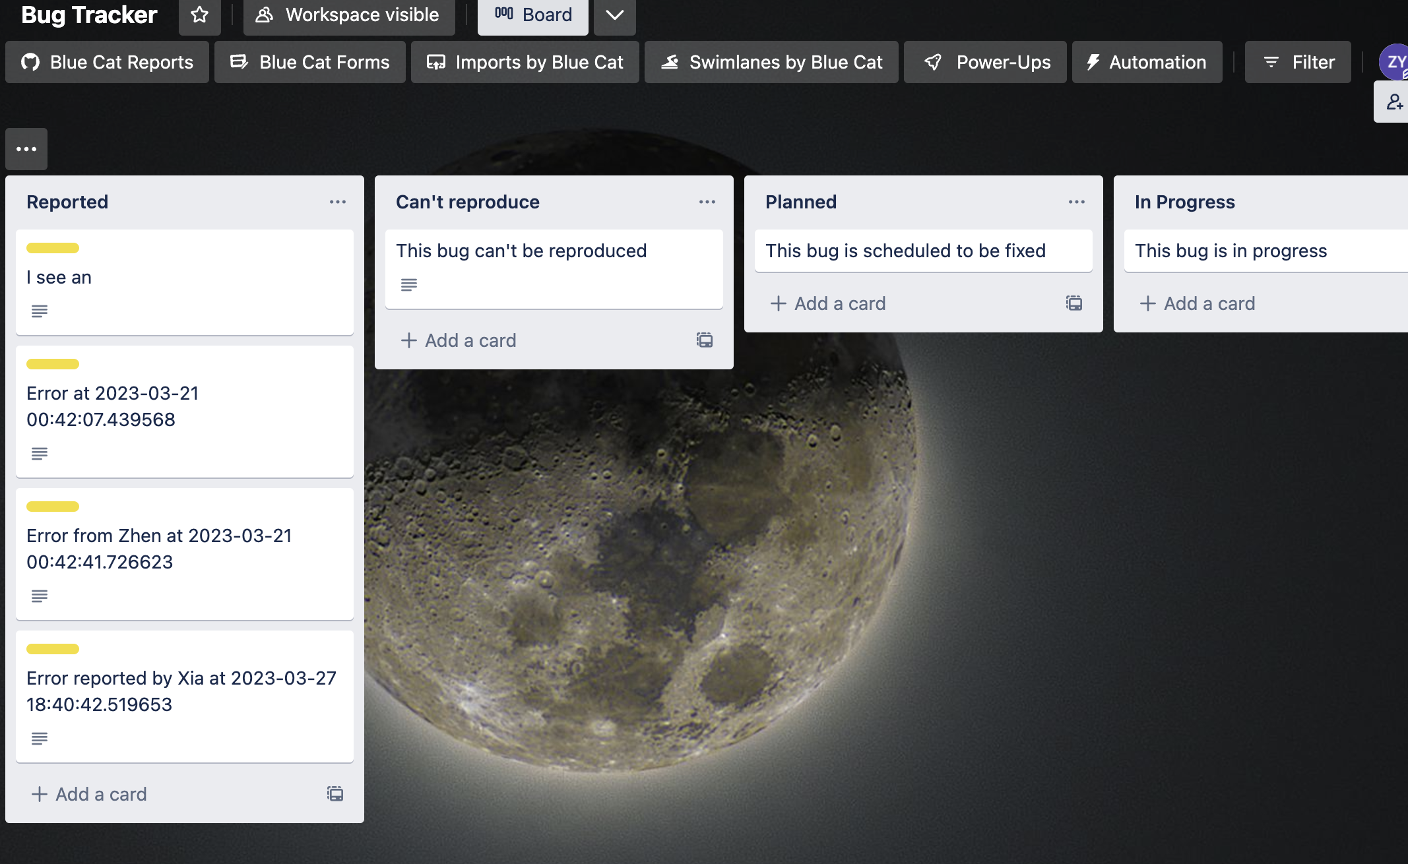

3. click more in the right menu

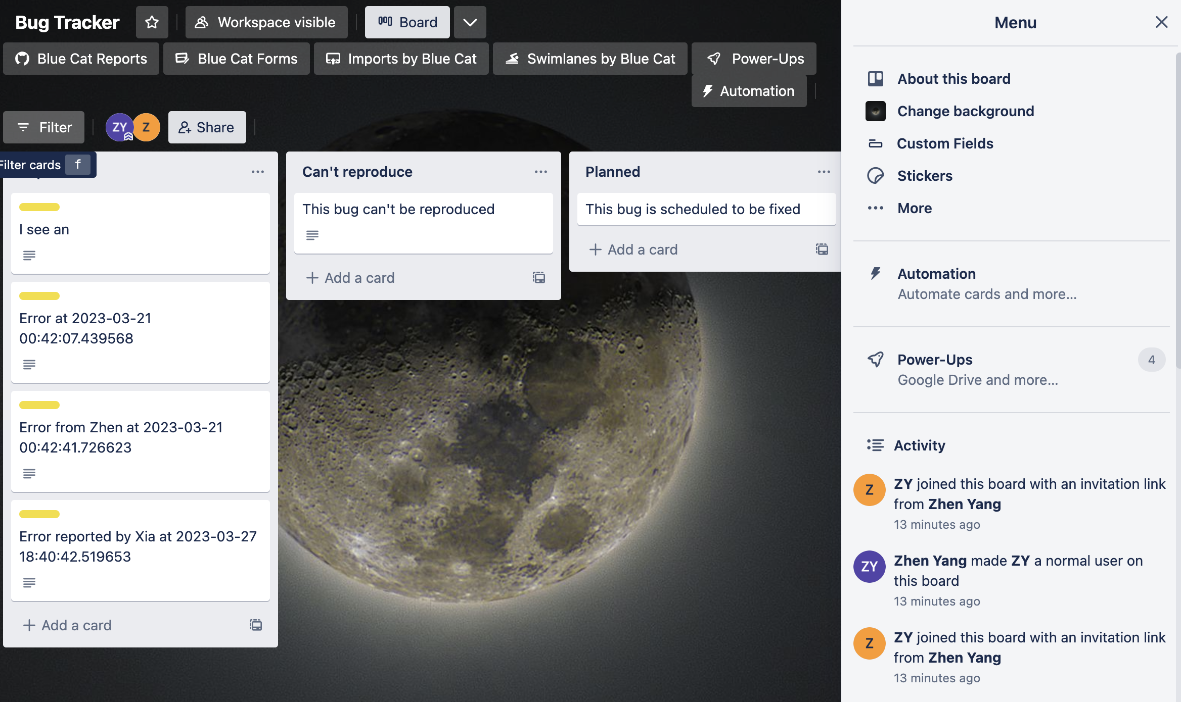

1. click copy board

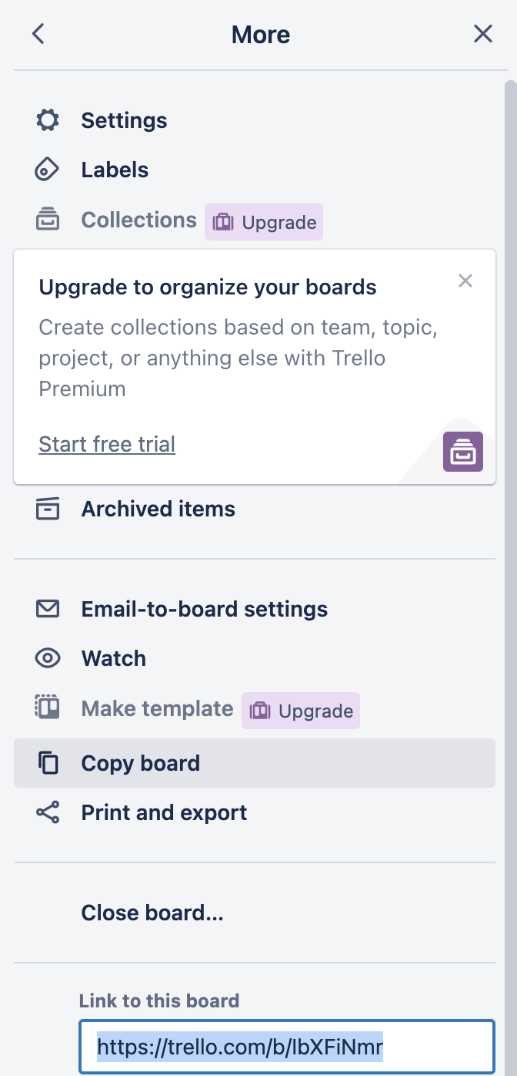

1. to link the board to our application

A. Get your API key:

Visit the Trello API key page: https://trello.com/app-key

Log in with your Trello account, if you haven't already.

You will see your API key displayed on the page. Make a note of it, as you'll need it later.

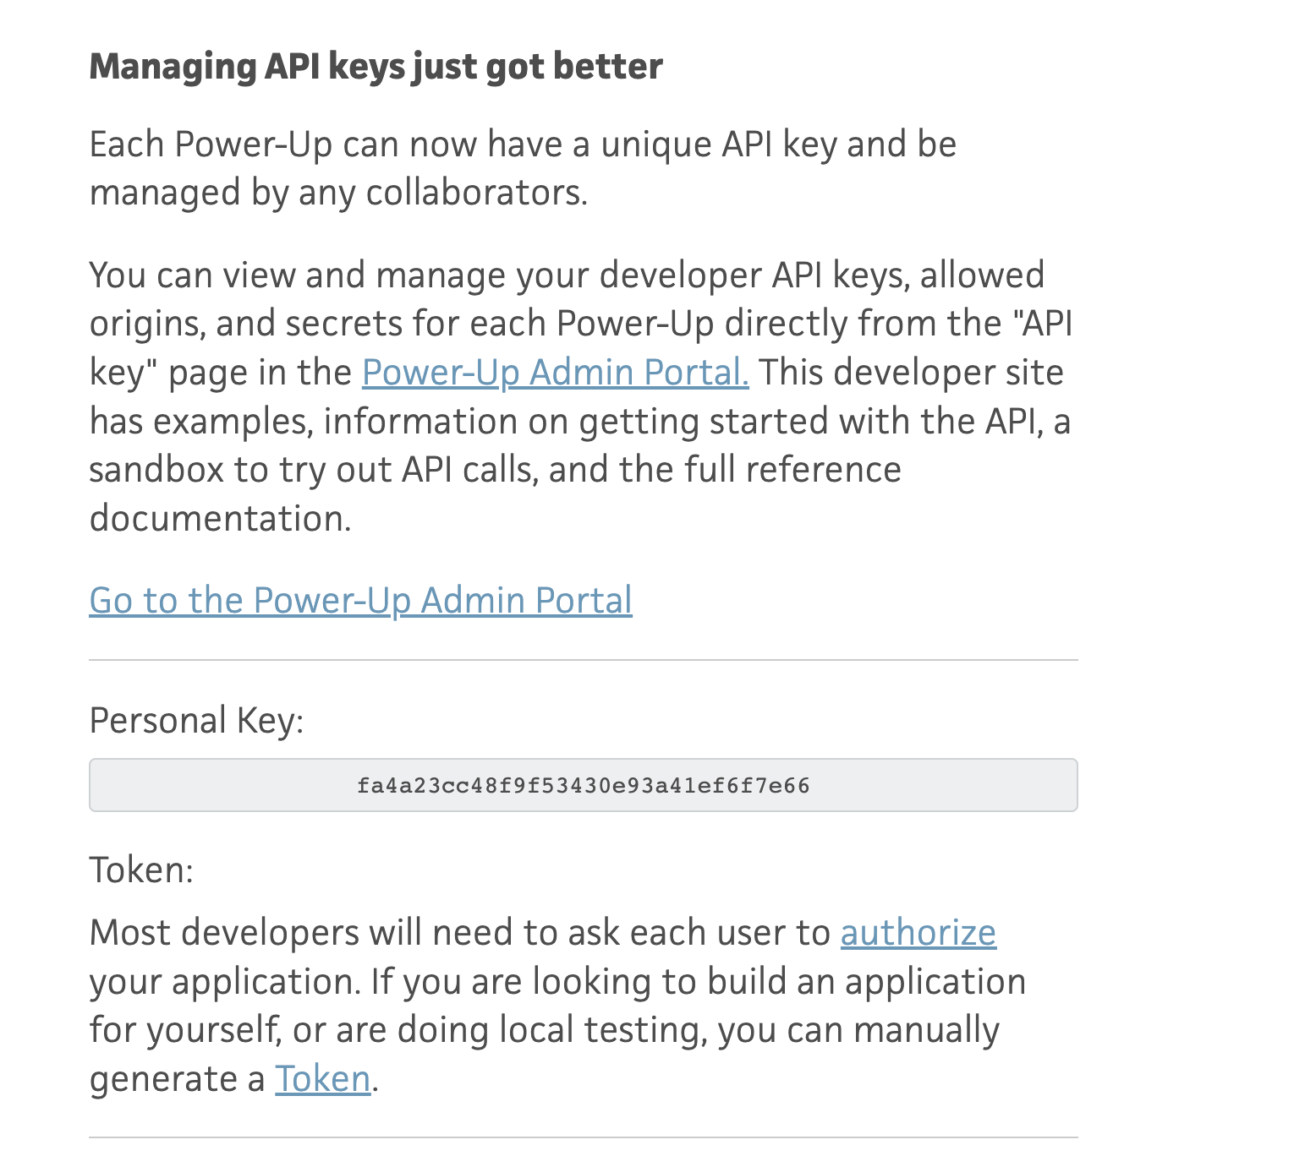

B. Generate your Trello token:

On the same API key page (https://trello.com/app-key), locate the "Token" section.

Click the "Token" link

1. paste the key and token to the application.py

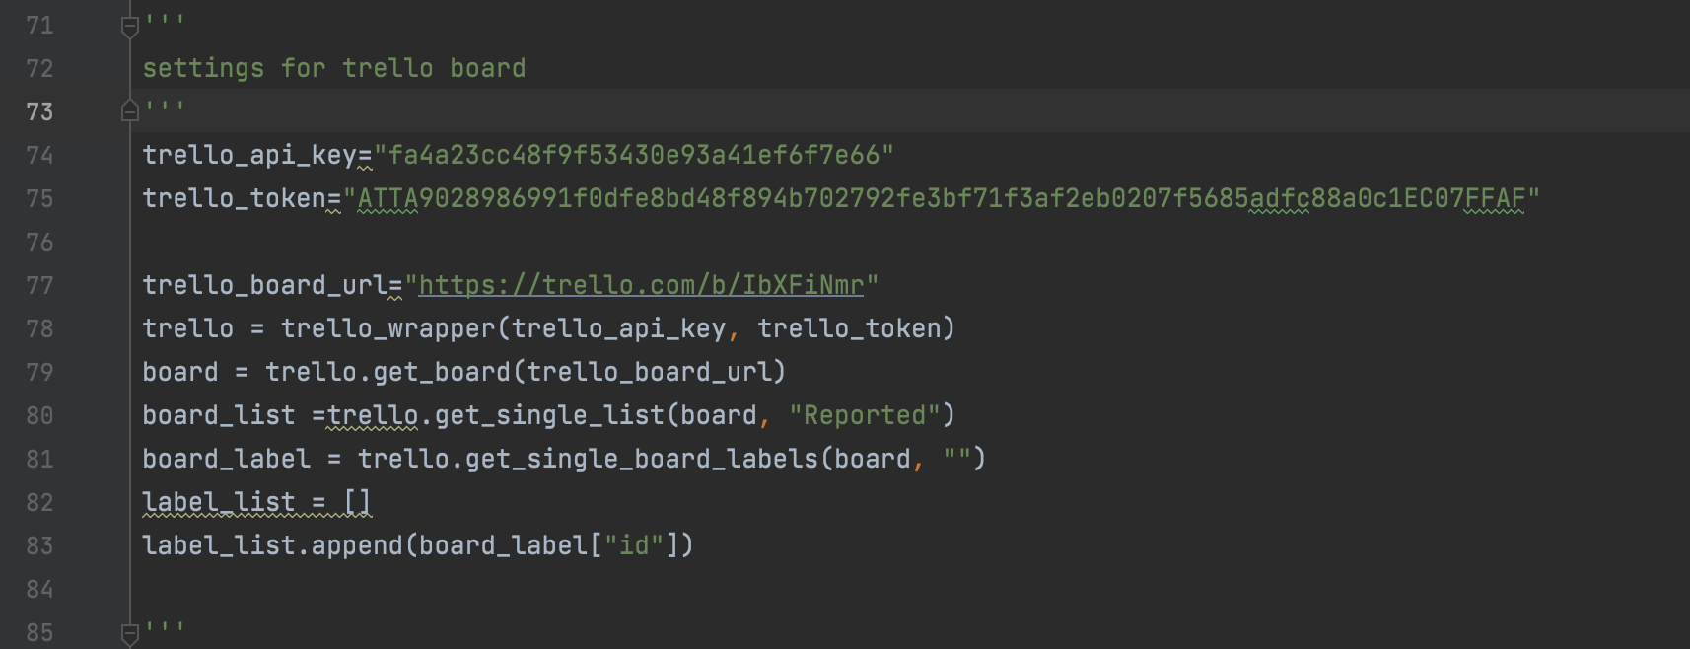

Replace the key, token and url variables with those of new board.

Set up a Trello account for the lab.

1. Register

We choose to go with google, after sign in google ([xiajiangw81x@gmail.com](mailto:xiajiangw81x@gmail.com)), then create an account with Trello.

2.

Copy the board that Zhen created previously to this new account. Go to the follow address

Board address :<https://trello.com/b/IbXFiNmr/bug-tracker>

Will be asked to log in (always use google to log in).

Once logged in, I received the following message:

After sending request, and zhen yang approved, clicked the board address again, was able to access the existing, then find copy board function to copy it see below.

Then go to get the APP Key

https://trello.com/app-key

But it did not work. Should show a personal key like below, but it didn’t.

